**Question 3**

**PL/SQL Procedure and Scheduler Job**

**Write a PL/SQL procedure to summarize the total hours worked by each employee**

**Configure a Scheduler Job to automate this report weekly**

1. Created normalized tables with:

- EMPLOYEES (master table) with `EMP_ID` as PRIMARY KEY

- EMPLOYEES_WORKHOUR_LOGS (transaction table) with:

FOREIGN KEY to enforce referential integrity

Indexes on frequently queried columns (EMP_ID, CREATED_DATE)

Added some dummy data for validating the PL/SQL procedure created below.

PL/SQL Procedure:

1. Implemented GENERATE_WORK_HOURS_REPORT with:

- Cursor-based processing for efficiency

- DBMS_OUTPUT for immediate results

Scheduler Job

1. created scheduler job EMPLOYEE_TOTAL_HOURS_WEEKLY_REPORT_JOB that runs at 8AM every Monday.

Evidences

Employee details table

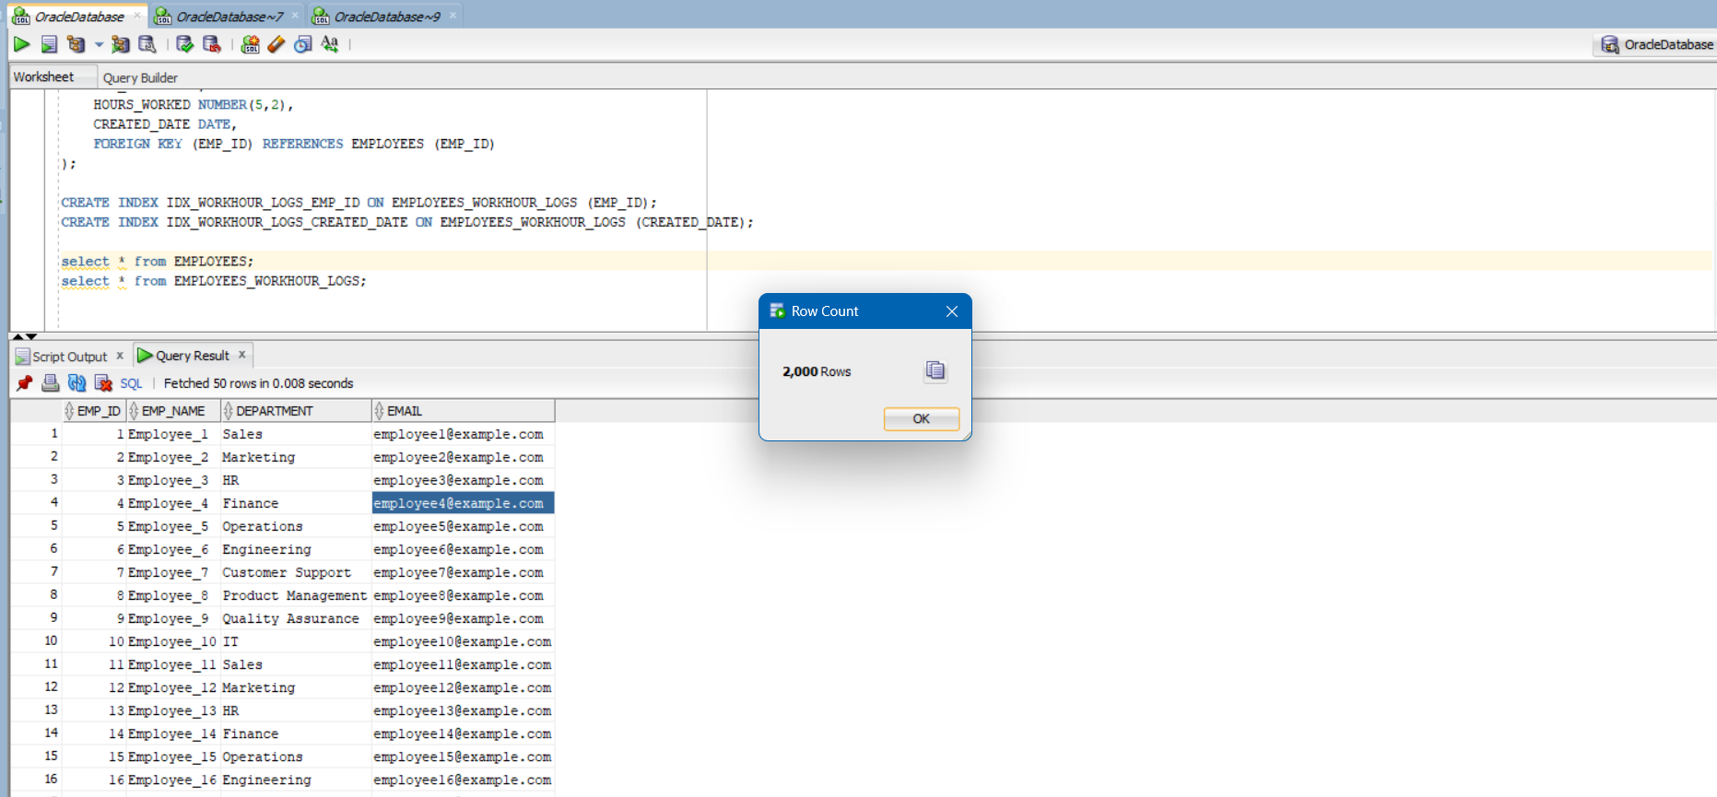

Added 250 entries for each employee containing the employee work hour details in the employees_workhour_logs table

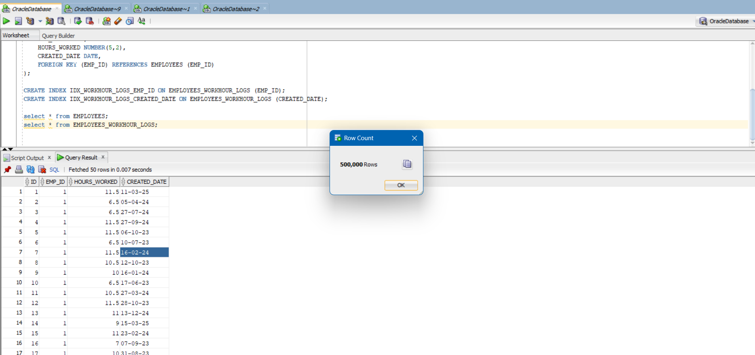

PL/SQL procedure for total hours worked by each employee

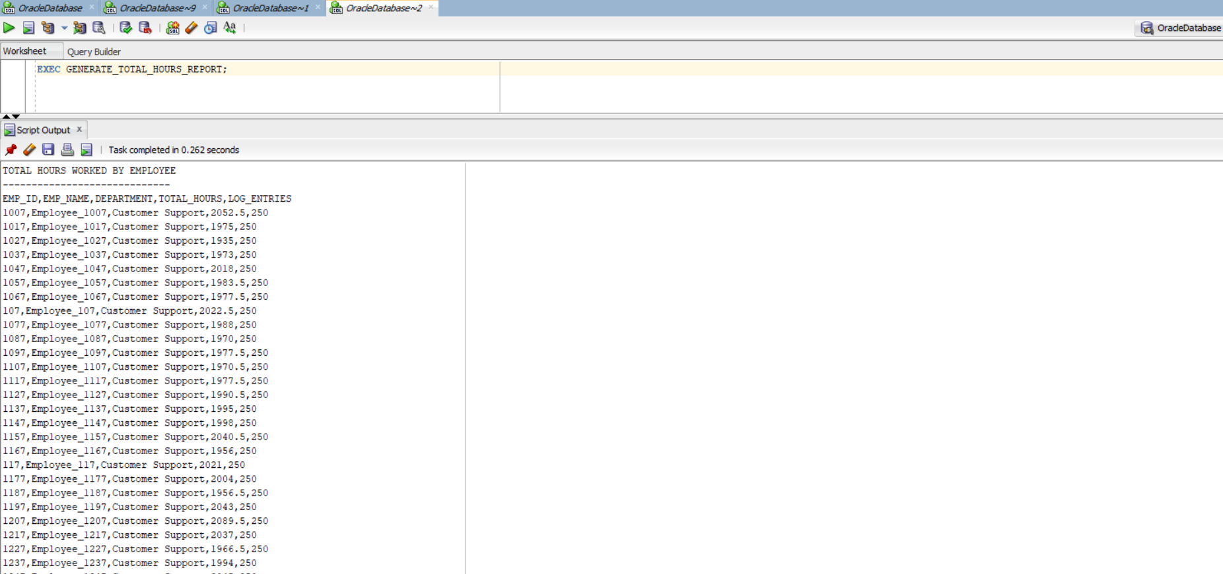

Scheduled job that runs every Monday at 8AM

